­Kanan Ibadzade

Efe Gur Bahadir, Jarred Chen, Zhi Hao Chong

Simple Harmonic Motion

OBJECTIVE

Calculate the spring constant “k” of a spring by using Hooke’s Law and N2L and comparing the results.

THEORY

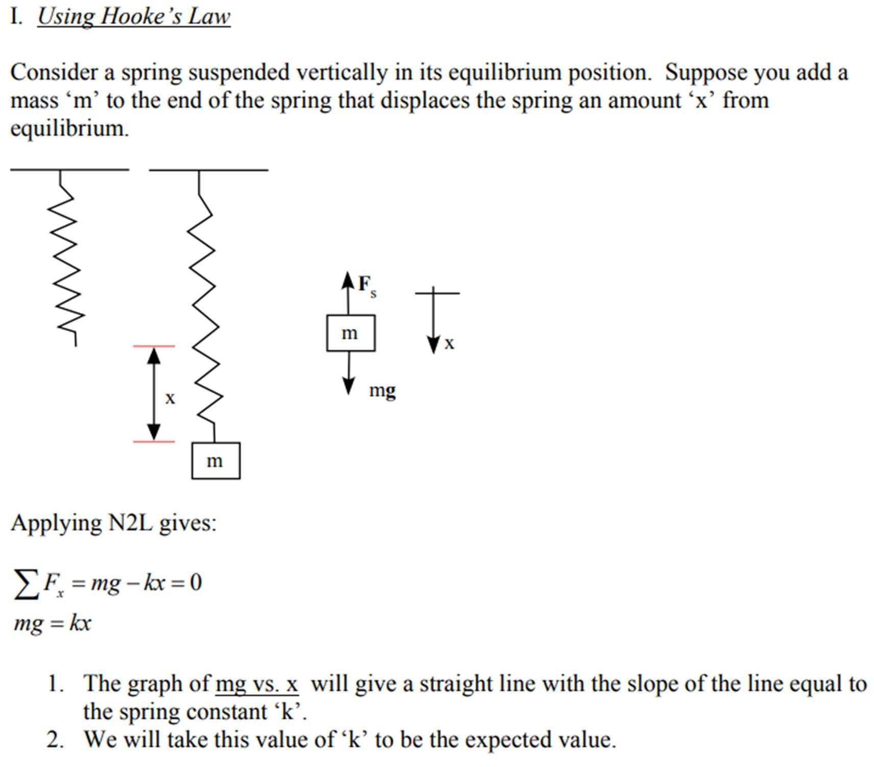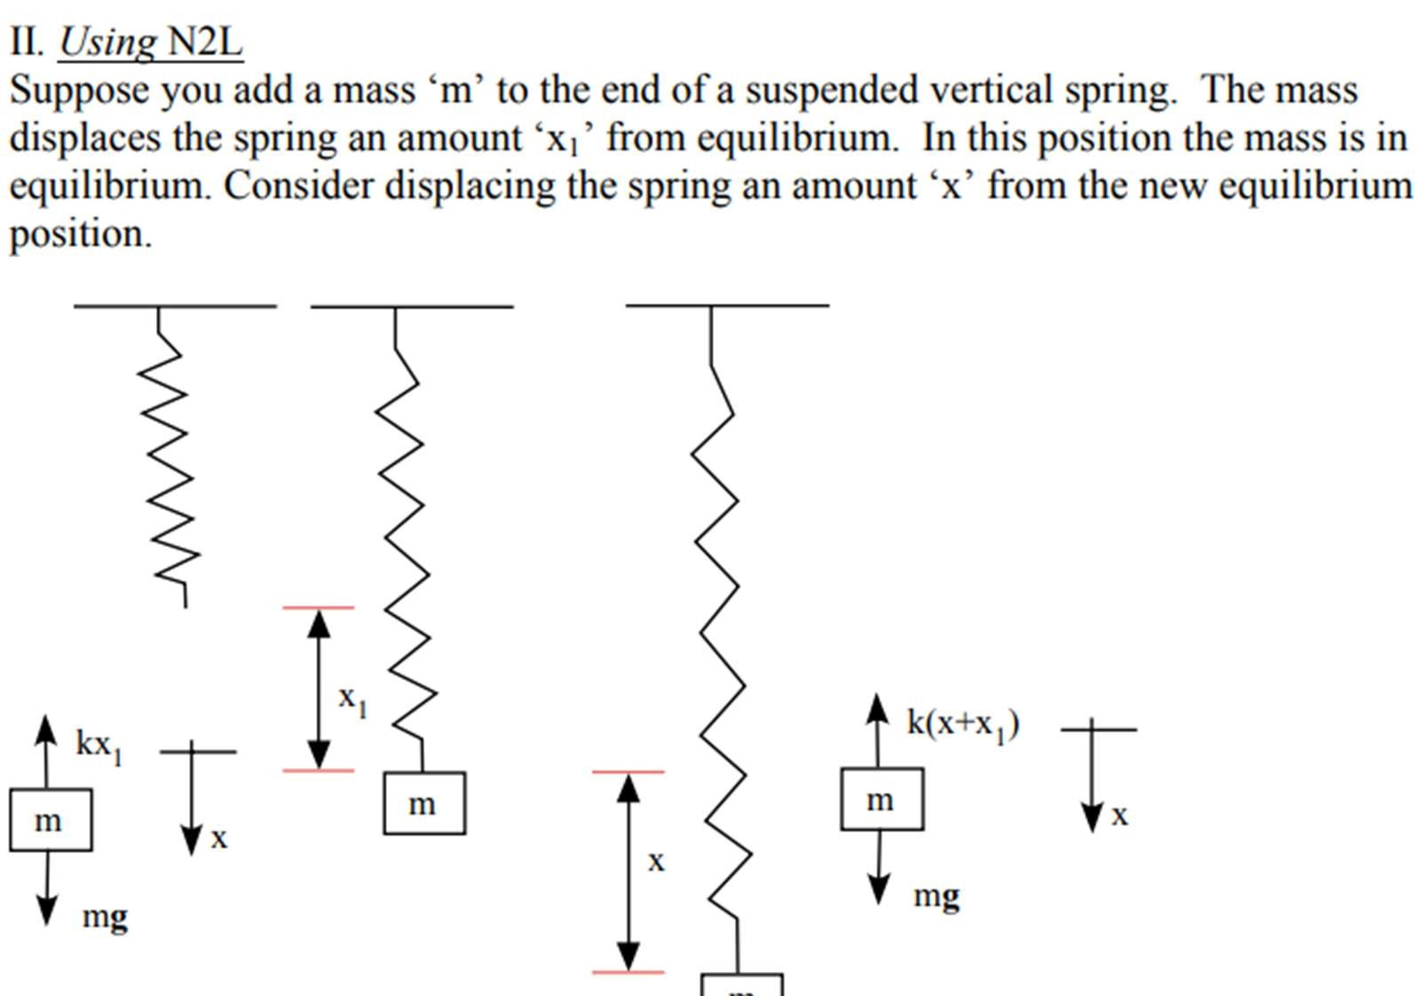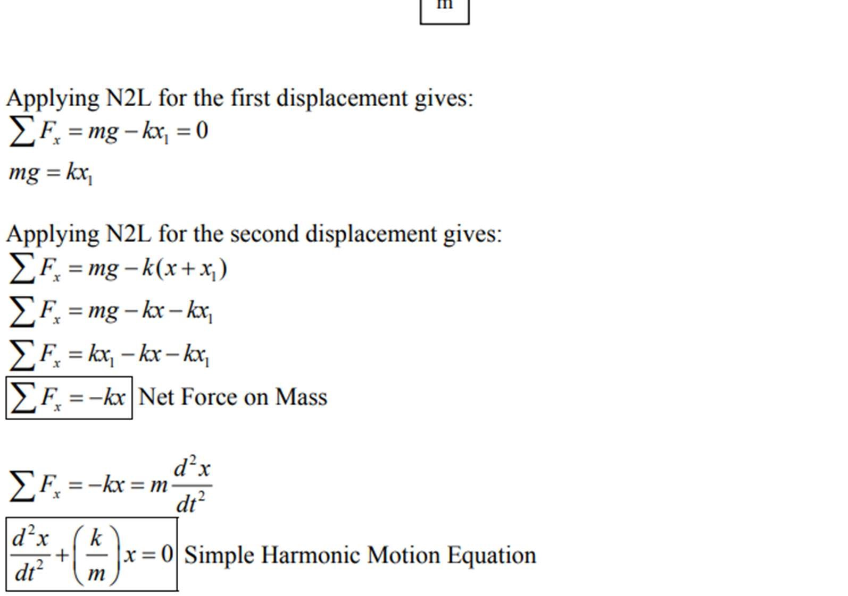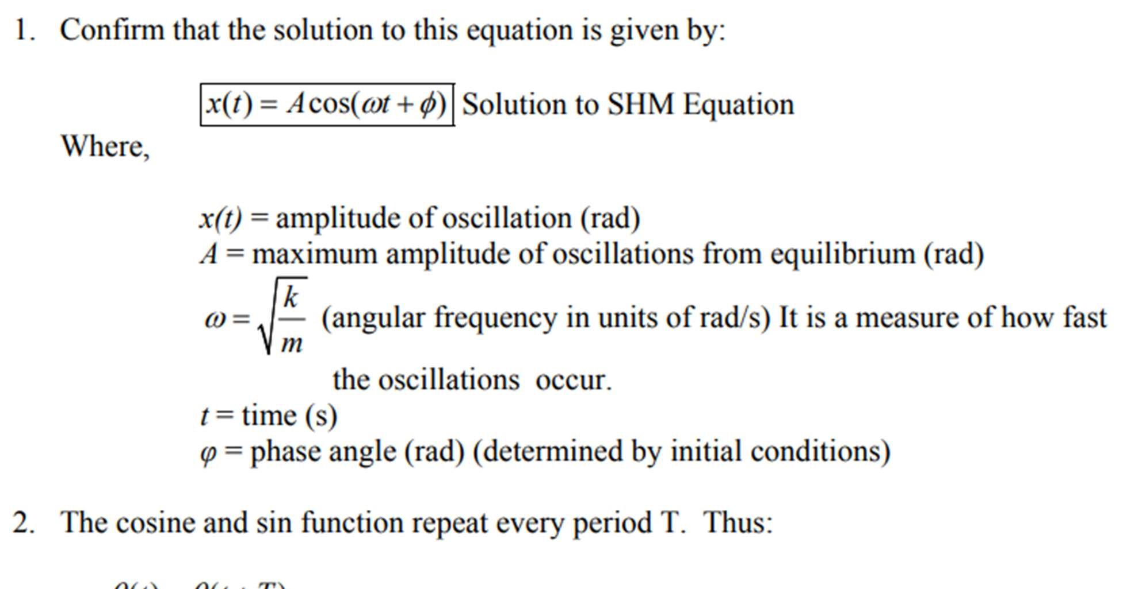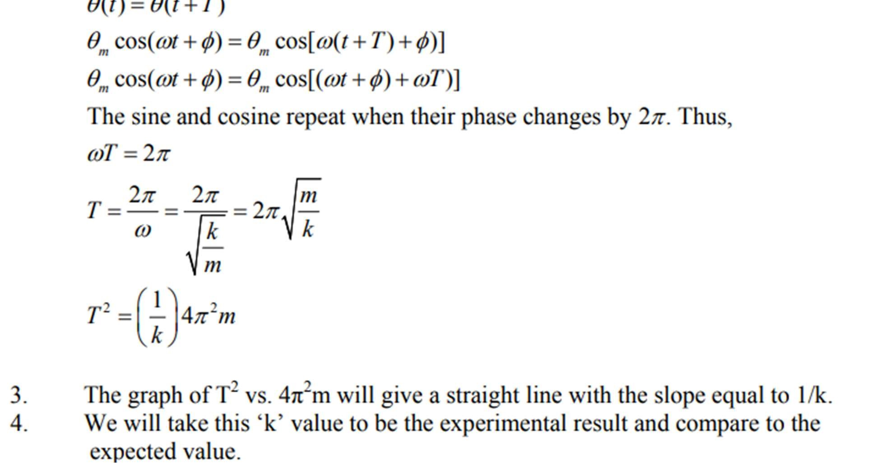

EQUIPMENT

1. 2-support rods and clamp

-support the weight of the spring and masses

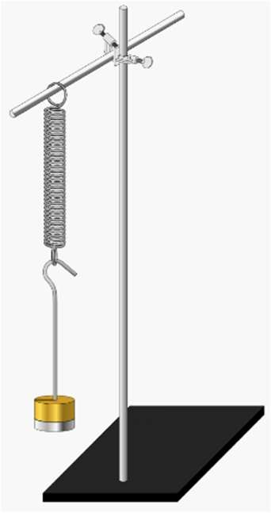

1. spring

-stretches and compresses with the movement of mass

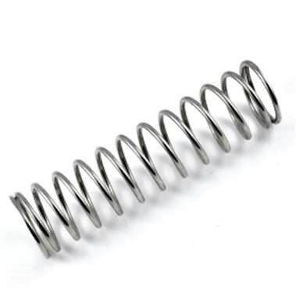

1. masses and hanger

-stretches the spring



1. stopwatch



-

record the time for 10 oscillations

1. 2-m stick

-measure the difference in the length of spring after stretching



1. Triple-Beam Balance

-measure the weight of masses and hanger



PROCEDURE

1. Attach the spring to the horizontal rod and measure the equilibrium position.
2. Attach 100g to the end of the spring and measure displacement “x” from equilibrium. 3
3. Displace the mass slightly from equilibrium and release.
4. Measure the time for 10 oscillations and calculate the period. Repeat for a total of 3 runs.
5. Repeat steps (1) - (4) for the masses listed in the table below and fill in the rest of the data.
6. Make a graph of mg vs. x using EXCEL and from the equation of best curve-fit determine the expected value of k.
7. Make a graph of Tave2 vs. 4π2m using EXCEL and from the equation of best curve-fit determine the experimental value of k.
8. Compare both values of k.

DATA

|  |  |  |  |  |  |  |
| --- | --- | --- | --- | --- | --- | --- |
| m (kg) | mg (N) | x (m) | t1 (s) | T1 (s) | t2 (s) | T2 (s) |
| 0.10036 ± 0.00001 | 0.98353 | 0.1100 ± 0.0005 | 8.32 | 0.832 | 8.10 | 0.810 |
| 0.15006 ± 0.00001 | 1.4721 | 0.1700 ± 0.0005 | 9.47 | 0.947 | 9.50 | 0.950 |
| 0.20022 ± 0.00001 | 1.9642 | 0.2300 ± 0.0005 | 10.15 | 1.015 | 10.67 | 1.067 |
| 0.25018 ± 0.00001 | 2.4543 | 0.2800 ± 0.0005 | 11.77 | 1.177 | 11.55 | 1.155 |
| 0.30013 ± 0.00001 | 2.9443 | 0.3400 ± 0.0005 | 12.64 | 1.264 | 12.76 | 1.276 |

|  |  |  |  |  |
| --- | --- | --- | --- | --- |
| t3 (s) | T3 (s) | Tavg (s) | Tavg2 (s) | 4π2m (kg) |
| 8.17 | 0.817 | 0.820 | 0.672 | 3.9621 |
| 9.55 | 0.955 | 0.951 | 0.904 | 5.9241 |
| 10.62 | 1.062 | 1.048 | 1.098 | 7.9044 |
| 11.69 | 1.169 | 1.167 | 1.362 | 9.8767 |
| 12.67 | 1.267 | 1.269 | 1.610 | 11.849 |

GRAPH

1. mg vs. x

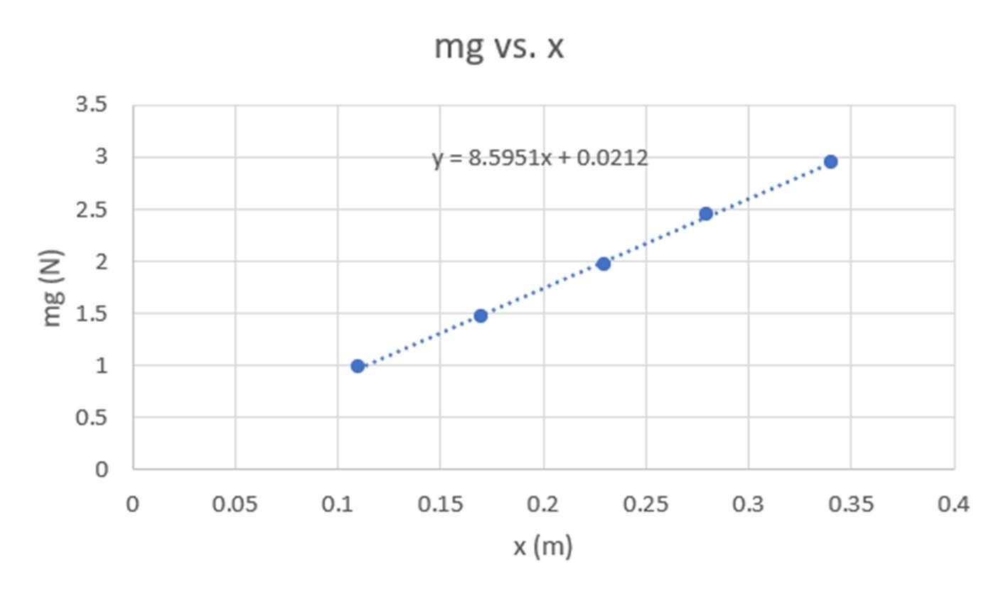

1. Tave2 vs. 4π2m

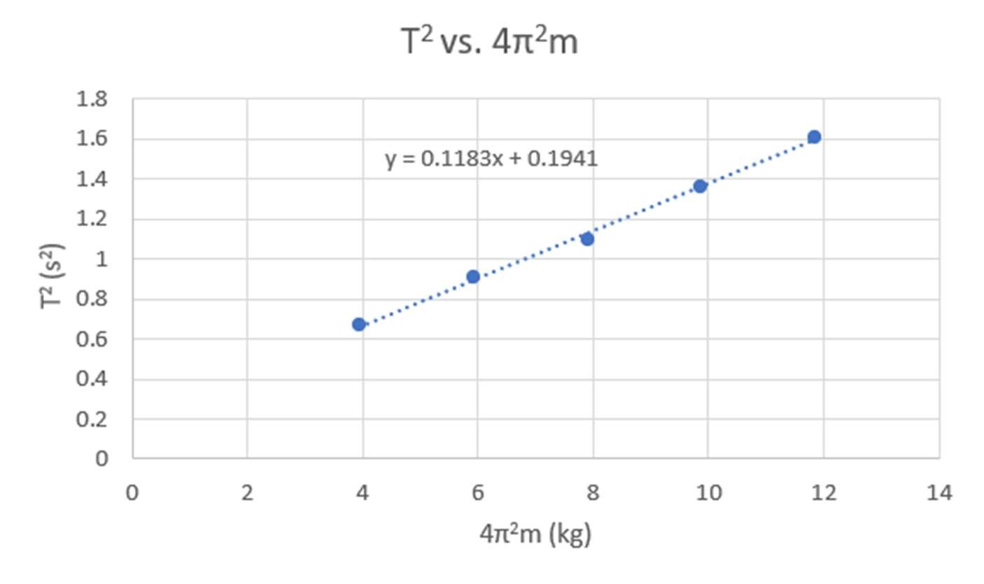

CALCULATIONS

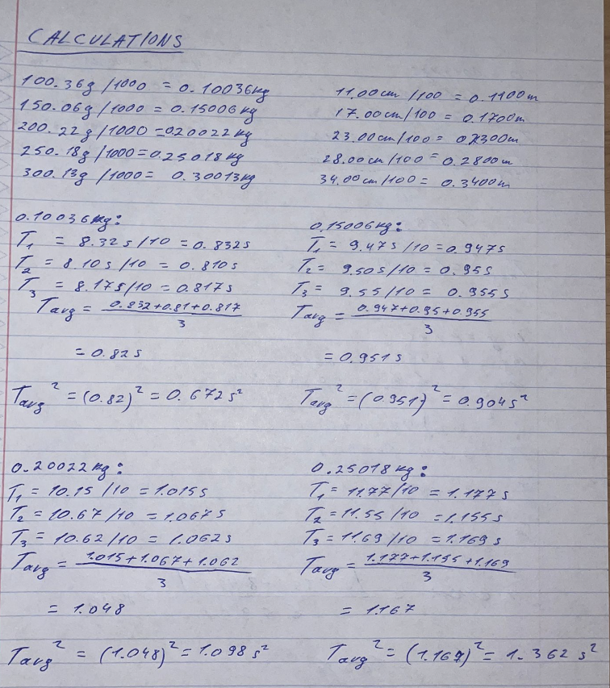

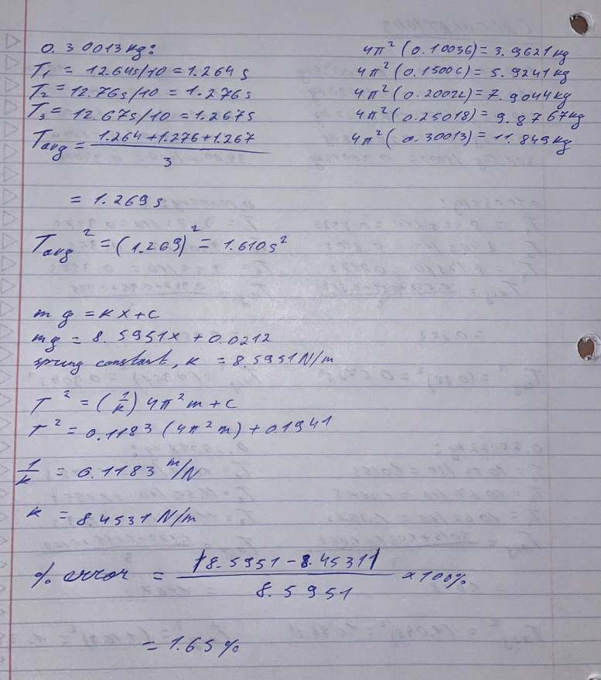

CONCLUSION & RESULTS

The slope of the mg vs. x graph yields the predicted value of the spring constant or k. Conversely, the experimental value is ascertained via the utilization of the graph's slope, Tave2 vs. 4π2m. Our lab's results show that the experimental value was 8.4531 N/m, while the predicted value was 8.5951 N/m. It is determined by calculating the percent error that the experimental value of the spring constant deviates 1.65% from the predicted value. This lab's goal is to compute a spring's spring constant, or "k," using N2L and Hooke's Law, and then compare the results. I was able to achieve this goal with the help of my lab companions and the lecturer. Using the data we gathered, we plotted two graphs: mg vs. x and Tave2 vs. 4π2m. Using the equation of the best curve-fit line, we were able to determine the expected and experimental values of the spring constant. In this experiment, the systematic mistake is the slightly distorted spring. Each recoil is uneven due to the malformed spring, which also affects how long it takes for 10 oscillations. The experimental spring constant value deviates from the predicted value, 8.5951 N/m, as a result. The random mistake that occurred in this lab was the air friction. The masses linked to one end of the spring will rise when the spring is stretched and released. The air resistance will delay the movement of masses as they rise, lengthening the time required for ten cycles.